**Lab 1: Layout**

**Objective:** To create the HTML structure for an ecommerce webpage

**Editor Used**: VS Code

HTML:

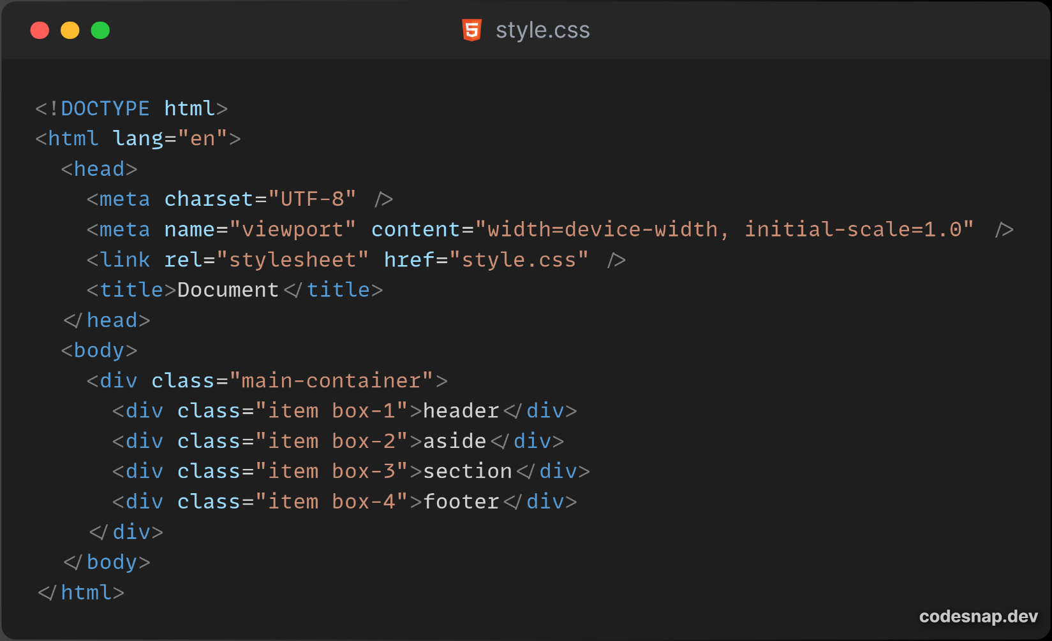

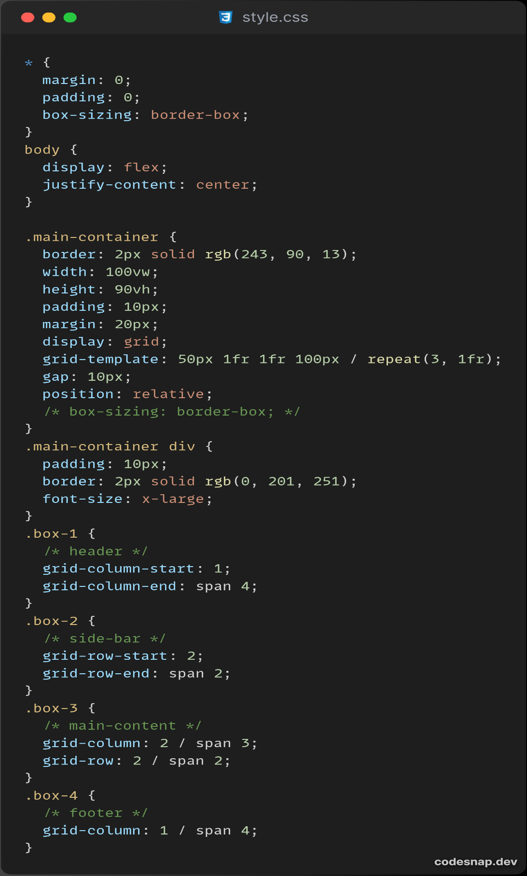CSS:

**Conclusion:** The HTML code provides a structured foundation for an ecommerce webpage, organized into main sections and boxes for content placement.

**Lab 2: Navigation**

**Objective:** To add Navigation on sidebar with dropdown.

**Editor Used**: VS Code

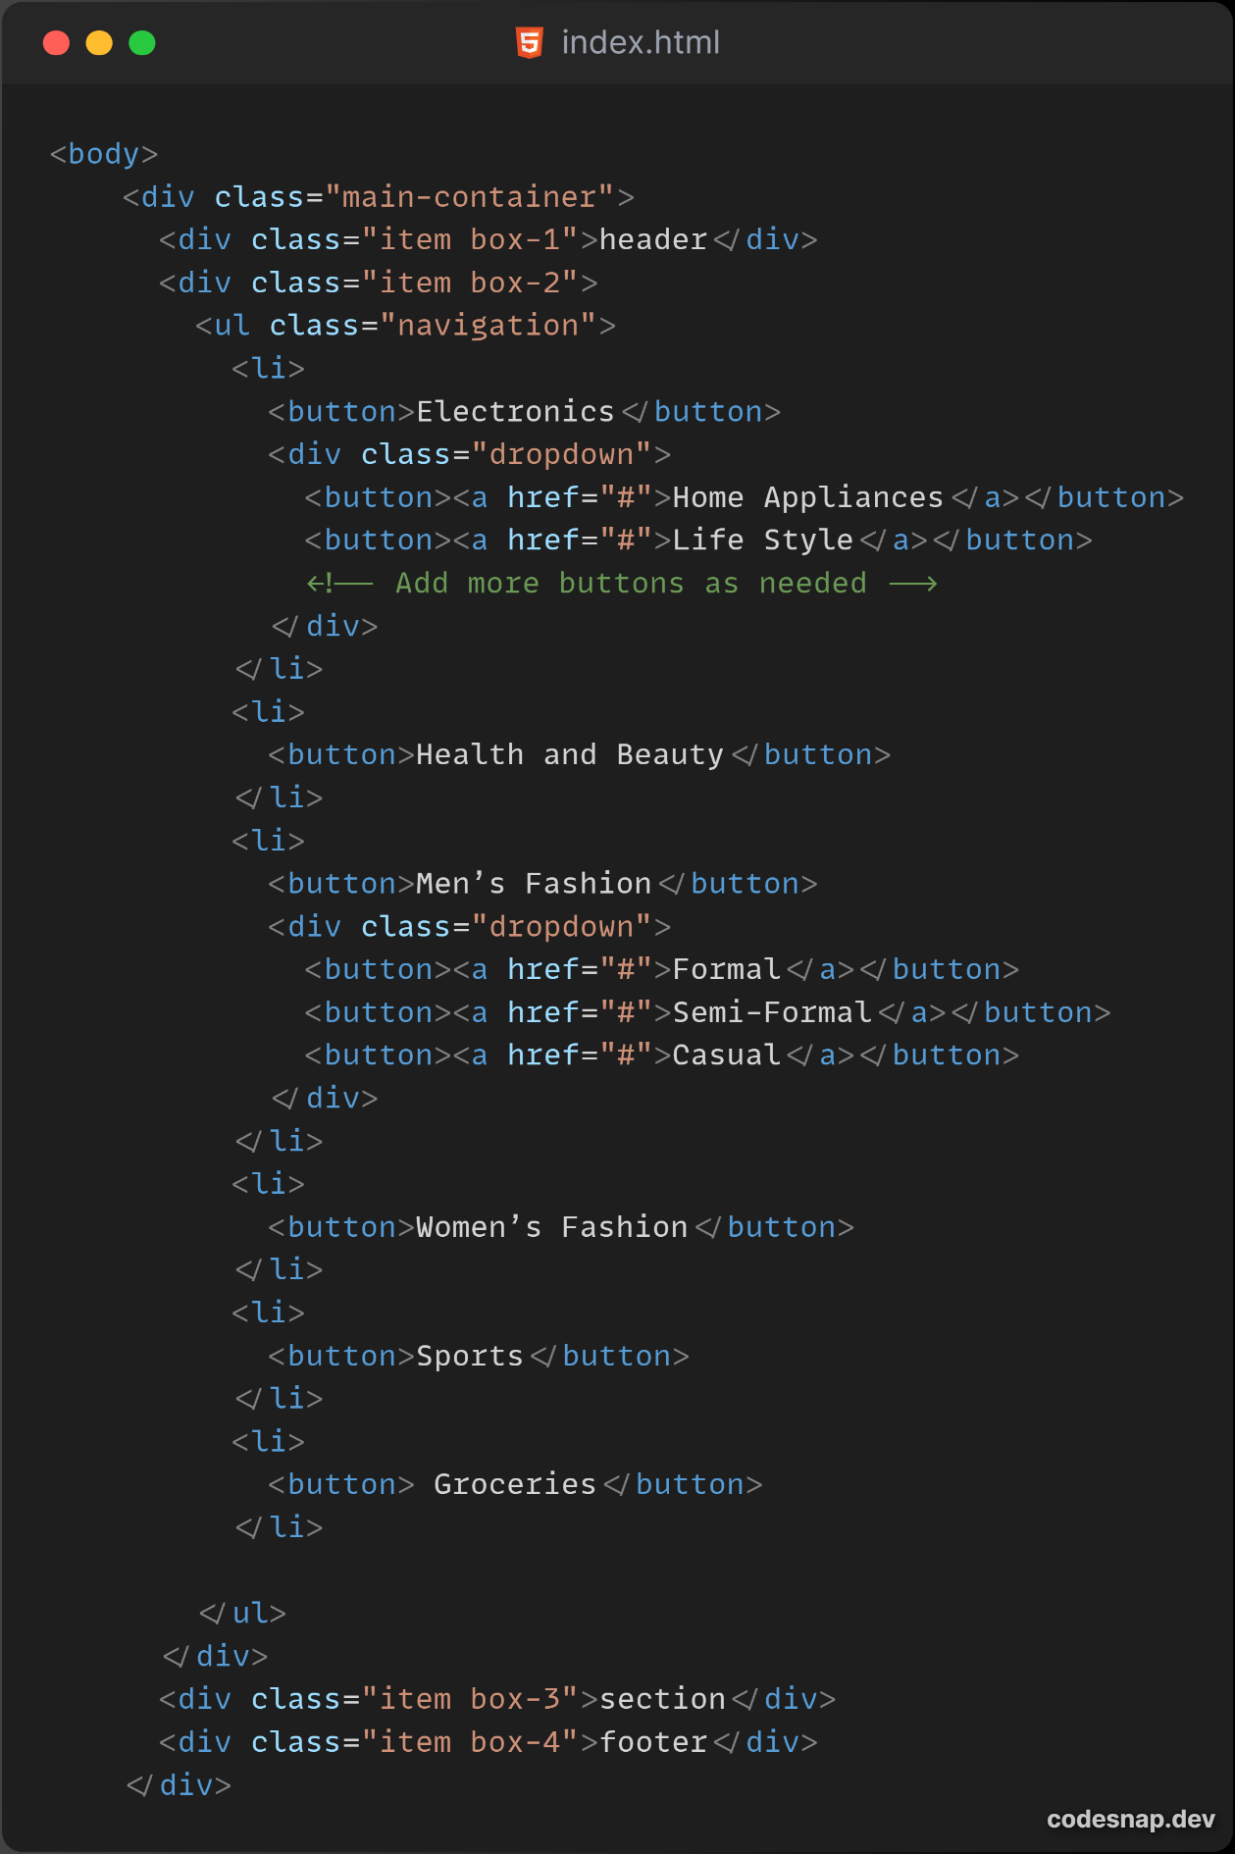HTML:

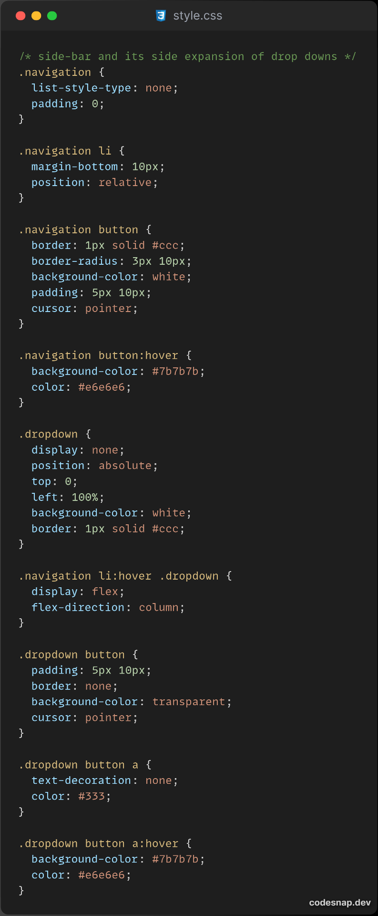CSS:

**Conclusion:** This HTML/CSS code styles a navigation menu with dropdown functionality for an ecommerce webpage.

**Lab 3: Add Logo**

**Objective:** In the header section, create a logo and add it with transparent background and a title to your

e-commerce site in a fancy font.

**Editor Used**: VS Code

HTML:

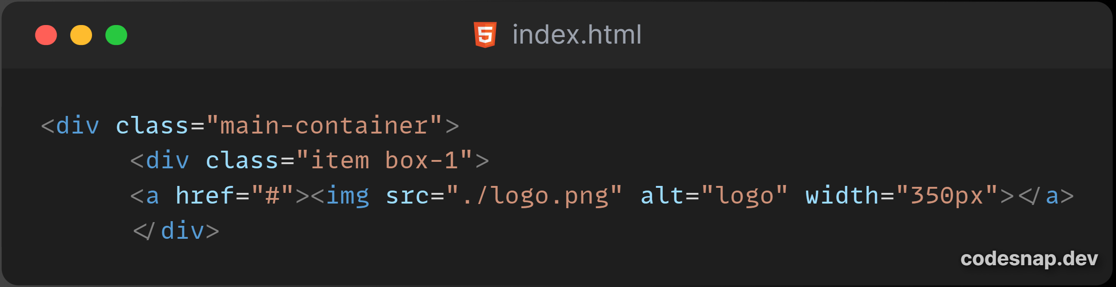

CSS:

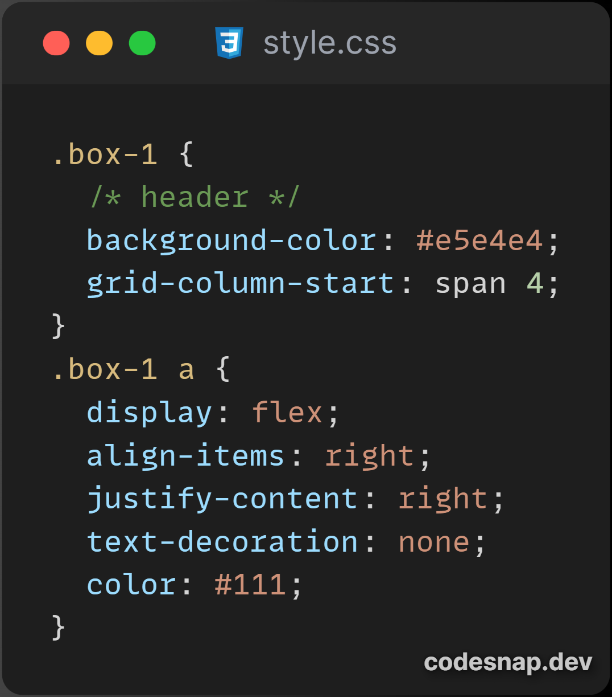

**Conclusion:** This HTML/CSS code is for adding logo in e-commerce website.

**Lab 4: Rounded Corners**

**Objective:** Change the corners of the different sections and menu items of your e-commerce platform into rounded corners as instructed.

**Editor Used**: VS Code

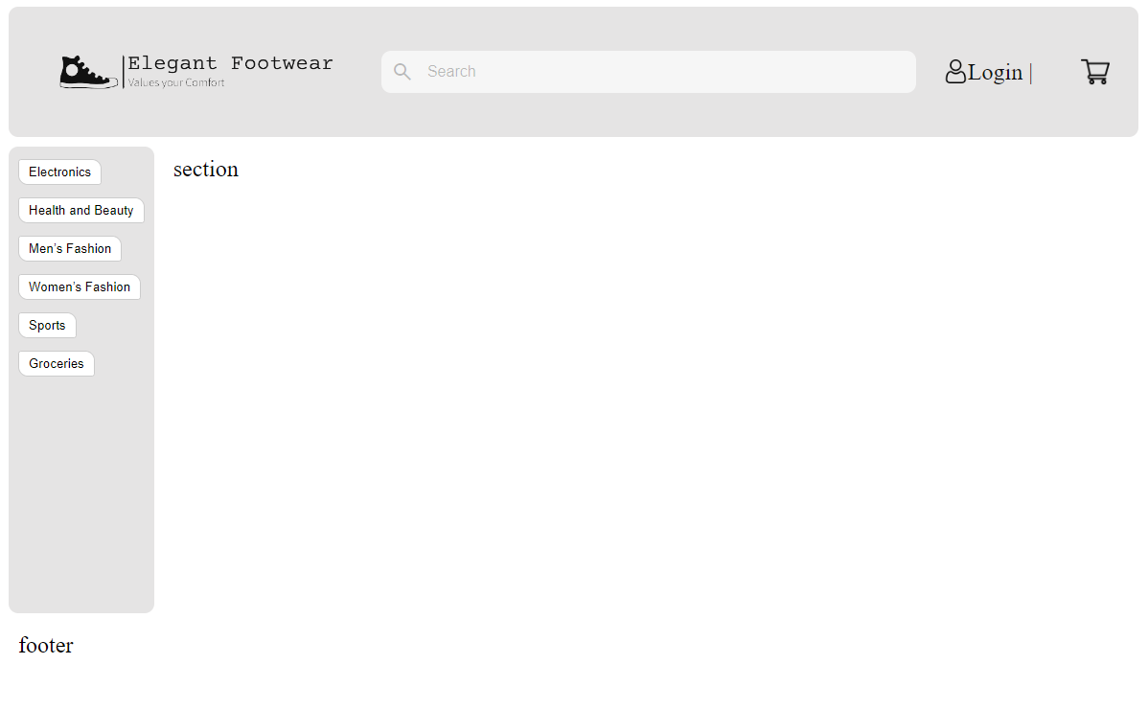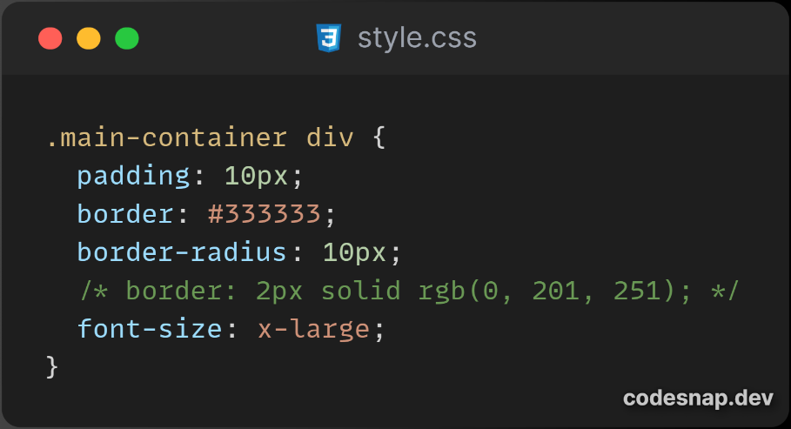**CSS:**

**Conclusion:** The above code shows the use of border-radius to make the rounded corners of layout.

**Lab 5: Add Search Box**

**Objective:** Add a search box on the right top of our template.

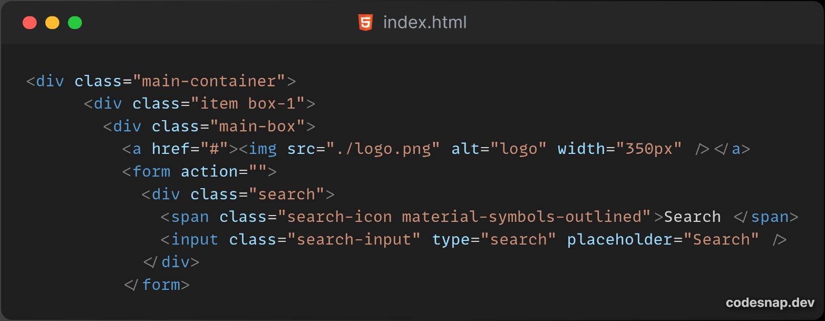**Editor Used**: VS Code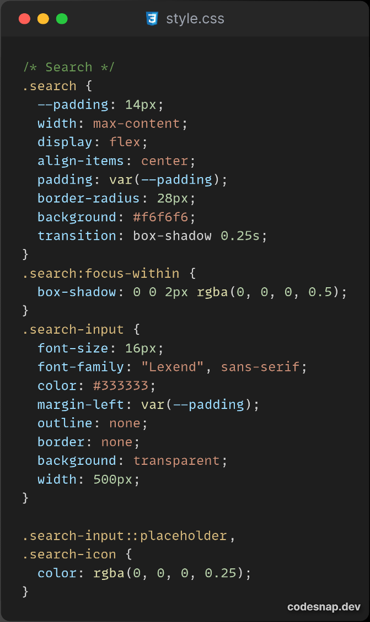

**Conclusion:** The above HTML/CSS adds a search bar on the header section of website.